Comprehension

Crab

I understand what I read.

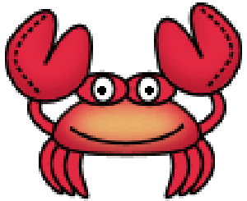

          Accuracy Anchor

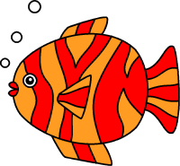

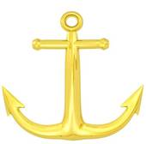

I can read the words.



Fluency Fish

I can read accurately with expression, and understand what I read.



Expanding Vocabulary

I know, find, and use interesting words.

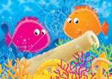

(expanding pufferfish)