**Longitudinal study:** studies a person or group of people over an extended period of time.

**Cross-sectional study:** compares individuals of various ages at one point in time.

**Genome:** the set of complete instructions for making an organism.

**Chromosome:** the genetic master code for the body. It is made up of DNA. There are 46 chromosomes (23 from each parent) in the nucleus. Males have both an X and Y chromosome. Girls have 2 X chromosomes. The father genetically determines the sex of the baby.

**DNA:** a complex molecule containing the genetic information that makes up the chromosomes.

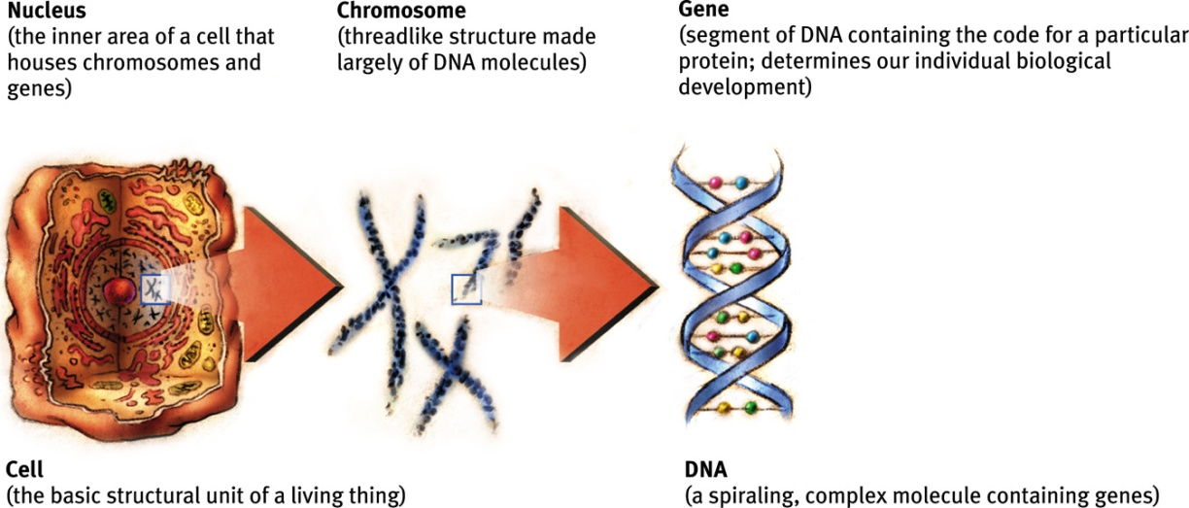

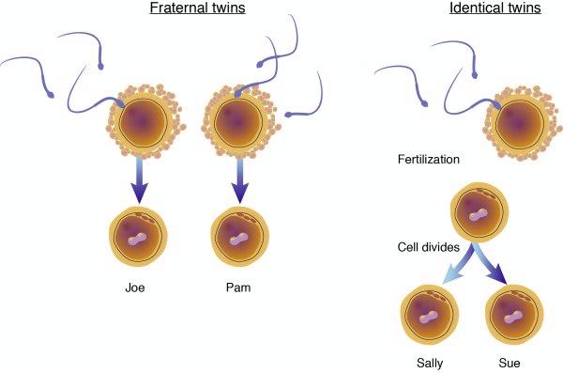**Identical twins:** twins who develop from a single fertilized egg that splits in two, creating two genetically identical organisms.

**Fraternal twins:** twins who develop from separate fertilized eggs. They are genetically no closer than brothers or sisters, but they share a fetal environment.

**Prenatal period:** the period of pregnancy that begins with conception and ends 9 months later with birth.

**Conception:** the fertilization of the egg.

**Zygote:** the fertilized egg. The zygote stage lasts 2 weeks in which there is a period of rapid cell division. About day 10, the zygote attaches to the mother’s uterine wall.

**Differentiation:** cells choosing their specialization, such as a stomach or a brain cell.

**Embryo:** the developing human organism from 2 – 8 weeks (2nd month). At this time organs begin to form and function (the heart beats, liver produces red cells, etc.), the umbilical cord forms, and arms and legs are beginning to form.

**Fetus:** the developing human organism from 9 weeks after conception to birth. At this time hands and feet are developing, at around the 6th month, organs such as the stomach have developed enough to allow a premature born fetus a chance of survival. The fetus is also responsive to the mother’s voice.

**Teratogens:** toxic substances that can harm the embryo or fetus if ingested or contracted by the mother. Examples are alcohol, drugs, nicotine, HIV, AIDS, etc.

**Fetal Alcohol Syndrome (FAS):** physical and cognitive abnormalities in children caused by a pregnant woman’s heavy drinking. Some characteristics include: disproportioned head, learning disabilities, emotional problems, etc.

**Neonate:** newborn

**Apgar test:** a simple and repeatable method to assess the health of a [newborn](http://en.wikipedia.org/wiki/Newborn) immediately after [birth](http://en.wikipedia.org/wiki/Childbirth). It rates 5 categories (skin color, pulse rate, reflexes, muscle tone, and breathing) on a scale from 0 – 2, with the final score ranging from 0 – 10.

**PKU (Phenylketonuria):** a condition that makes it impossible for babies to metabolize certain proteins.

**Reflexes:** survival actions with which a baby is born.

|  |  |
| --- | --- |
| Moro or“Startle” reflex | An outstretching of the arms and legs in response to a loud noise or sudden physical change. |
| Babinski reflex | In response to a touch on the bottom of the foot, the infant’s toes will splay outward and arch back. In adults, the toes just curl in. |
| Sucking reflex | Occurs when an object touches the lips. |
| Rooting reflex | The turning of an infant's head toward a stimulus such as a breast or hand. |
| Grasping reflex | In response to a touch on the palm of the hand, an infant will grasp. |
| Swallowing | An infant can swallow, though this reflex is not yet well coordinated with breathing. |
| Stepping | If held so that the feet just touch the ground, an infant will show “walking” movements, alternating the feet in steps. |

**Sudden Infant Death Syndrome (SIDS):** the sudden death of an infant under 1 year of age that cannot be explained after a thorough investigation is conducted. Typically the infant is found dead after having been put to bed, and exhibits no signs of having struggled. SIDS is the leading cause of death among infants aged 1–12 months, and is the third leading cause overall of infant mortality in the United States.

**Habituation:** a decrease in responsiveness with repeated stimulation. Ex. a baby no longer being excited by a toy.

**Schema:** a concept or framework that organizes and interprets information.

**Assimilation:** the process of absorbing new information into an existing schema.

**Accommodation:** the process of adjusting old schemas or developing new ones to incorporate new information.

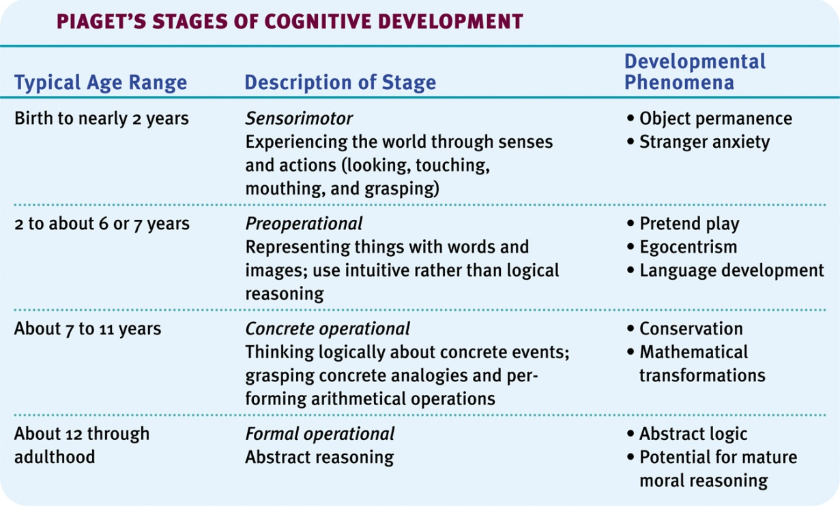

**Object permanence:** the understanding that objects and people continue to exist even when they cannot be seen, heard, or touched. Develops in the sensorimotor stage.

**Egocentrism:** the inability to consider another person’s point of view. Ex. thinking daddy wants a toy truck for his birthday because that is what you would like. Found in the preoperational stage.

**Animistic thinking:** believing that inanimate objects have feelings. Found in the preoperational stage.

**Conservation:** the understanding that two equal quantitites remain equal even thought their form or appearance is rearranged. Ex. understanding that your sandwich is the same size if it is cut into halves or quarters.

**Theory of mind:** is the ability to attribute mental states ([beliefs](http://en.wikipedia.org/wiki/Belief), [intents](http://en.wikipedia.org/wiki/Intention), [desires](http://en.wikipedia.org/wiki/Desire_(emotion)), [pretending](http://en.wikipedia.org/wiki/Role-playing), [knowledge](http://en.wikipedia.org/wiki/Knowledge), etc.) to oneself and others and to understand others have beliefs, desires, and intentions that are different from one's own.

**Autism Spectrum Disorder:** disorders that are typically characterized by social deficits, communication difficulties, stereotyped or repetitive behaviors and interests, and in some cases, cognitive delays.

**Strange Situation test:**

* **Secure attachment:** forms when parents or caregivers consistently meet the infant’s needs by being warm and responsive. Securely attached infants tent to be well-adjusted, form successful social relationships, and perform better at school. During the Strange Situation test, they freely explore the environment, show moderate anxiety in the presence of strangers and some separation anxiety but is easily comforted upon the caregiver’s return (the reunion).
* **Insecure:** forms when parents or caregivers fail to fully meet the infant’s needs by being neglectful and inconsistent. Insecure infants tend to form shallow relationships, appear withdrawn and sometimes display an insatiable need for affection.

1. **Insecure-ambivalent:** during the Strange Situation test, the infant shows a great deal of anxiety, engages in little exploration, becomes distressed in the absence of the caregiver and in the presence of a stranger. Upon the return of the caregiver (the reunion), the infant is difficult to console.
2. **Insecure-avoidant:** during the Strange Situation test, the infant shows little distress in the absence of the caregiver and in the presence of a stranger. Upon the return of the caregiver (the reunion), the infant does not seek contact.

**Critical Period:** the period of time when an organism has heightened sensitivity for the development of a particular skill.

**Imprinting:** recognition of and attraction to members of one’s own species or to surrogates.

**Authoritarian:** a parenting style that has rigid rules, enforces strict punishments, and rarely, listens to the kids’ viewpoints. According to Baumrind, kids who grow up under the authoritarian parenting style tend to be moody, aggressive, and often lack good communication skills.

**Authoritative:** a parenting style that sets firm rules, makes reasonable demands, and listens to the kids’ viewpoints while insisting on responsible behavior. According to Baumrind, kids who grow up under the authoritative parenting style tend to be well-adjusted, goal oriented, and socially competent.

**Permissive:** a parenting style that sets few rules, makes minimal demands, and allows the kids to reach their own decisions. According to Baumrind, kids who grow up under the permissive parenting style tend to be impulsive, immature, and often fail to respect others, especially authority.

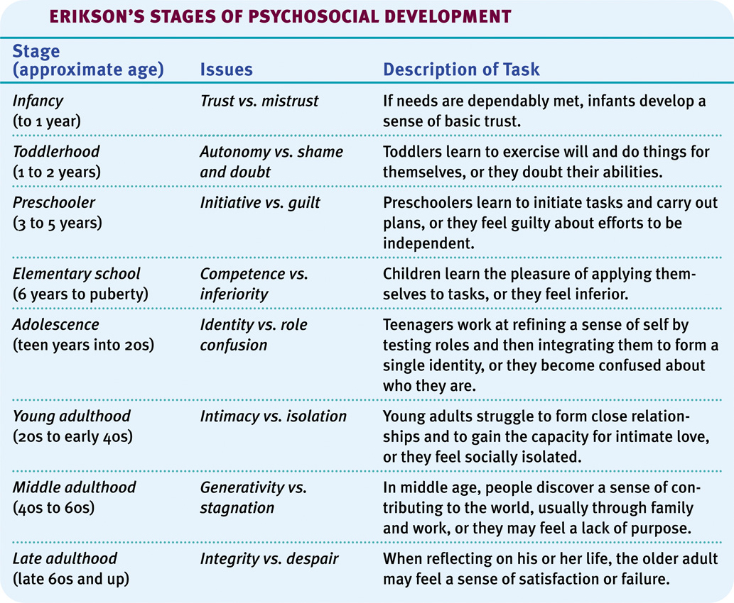**Neglectful:** a parenting style in which the parent is non-existent.

**Basic trust:** a sense that the world is predictable and reliable. Erikson attributes basic trust to early parenting and says that it gives a life-long attitude of basic trust rather than fear. This can be found in the *Infancy: trust vs. mistrust* stage of Erik Erikson’s stages of psychosocial development.

**Self-concept:** knowing who you are. This can be found in the *Toddlerhood: autonomy vs. shame and doubt* stage of Erik Erikson’s stages of psychosocial development.

**Five stages of grief:** the stages people go through when facing death or another terrible extreme fate.

1. **Denial:** "I feel fine."; "This can't be happening, not to me."  
   Denial is usually only a temporary defense for the individual.
2. **Anger:** "Why me? It's not fair!"; "How can this happen to me?"; '"Who is to blame?" because of anger, the person is very difficult to care for due to misplaced feelings of rage and envy.
3. **Bargaining:** "I'll do anything for a few more years."; "I will give my life savings if...", involves the hope that the individual can somehow postpone or delay death, or the tragedy.
4. **Depression:** "I'm so sad, why bother with anything?"; "I'm going to die soon so what's the point?"; "I miss my loved one, why go on?", the dying person begins to understand the certainty of death. Because of this, the individual may become silent, refuse visitors and spend much of the time crying and grieving.
5. **Acceptance:** "It's going to be okay."; "I can't fight it, I may as well prepare for it.", individuals begin to come to terms with their mortality, or that of a loved one, or other tragic event.

**Adolescence:** the period of time between puberty and adulthood when people experience physical, social, and moral changes.

**Puberty:** the physical beginnings of sexual maturity.

**Primary sex characteristics:** the organs needed for reproduction (ovaries in the female, testes in the male, and external genitalia).

**Secondary sex characteristics:** non-reproductive traits (enlargement of the hips and breasts in females, facial hair and deepening voice in males, the development of pubic and underarm hair in both females and males).

**Menarche:** a girl’s first menstrual period.

**Menopause:** the time of natural cessation of menstruation, also refers to the biological changes a woman experiences as her ability to reproduce declines.

**Morality:** accepted moral standards: standards of conduct that are generally accepted as right or proper.

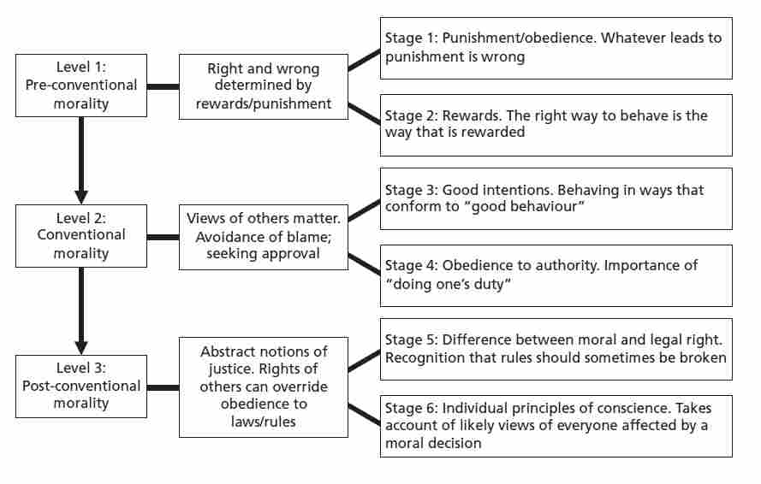

**Preconventional morality:** Before age 9, children show morality to avoid punishment or gain reward.

**Conventional morality:** By early adolescence, moral judgments are based on compliance w/society’s rules & values.

**Postconventional morality:** People develop personal standards of right & wrong, morality defined in terms of abstract principles of justice.

**Developmental Psych Key People:**

**John Locke:**  an early philosopher who said at birth our minds are a blank slate, a *tabula rasa*.

**Jean Piaget:** Swiss developmental psychologist who developed the stages of cognitive development (sensorimotor, preoperational, concrete operational, and formal operational).

**Lev Vygotsky:** Russian psychologist who developed the theory of mind.

**Mary Ainsworth:** a developmental psychologist who studied attachment through the Strange Situation Test.

**Harry Harlow:** a developmental psychologist who studied the effect of reassurance from the physical touch of a parent or caregiver and how it plays a key role in developing healthy physical growth and normal socialization.

**Konrad Lorenz:** studied the critical period and imprinting with geese.

**Diana Baumrind:** leading researcher on parenting styles (authoritarian, authoritative, and permissive)

**Erik Erikson:** a developmental psychologist who developed the theory that people enter eight stages of social development.

**Elisabeth Kübler-Ross:** developed the 5 stages of grief (denial, anger, bargaining, depression, and acceptance).

**G. Stanley Hall:** educational psychologist who looked at the effects of adolescence on education.

**Lawrence Kohlberg:** specialized in research on moral reasoning. He said people go through 3 stages of moral development (preconventional, conventional, and postconventional).

**Carol Gilligan:** criticized Lawrence Kohlberg for being too male centered. She said he favored a principled way of reasoning that was more common to makes, such as justice, while the moral concerns of women focus on caring and compassion.