Name:_______________________________________________

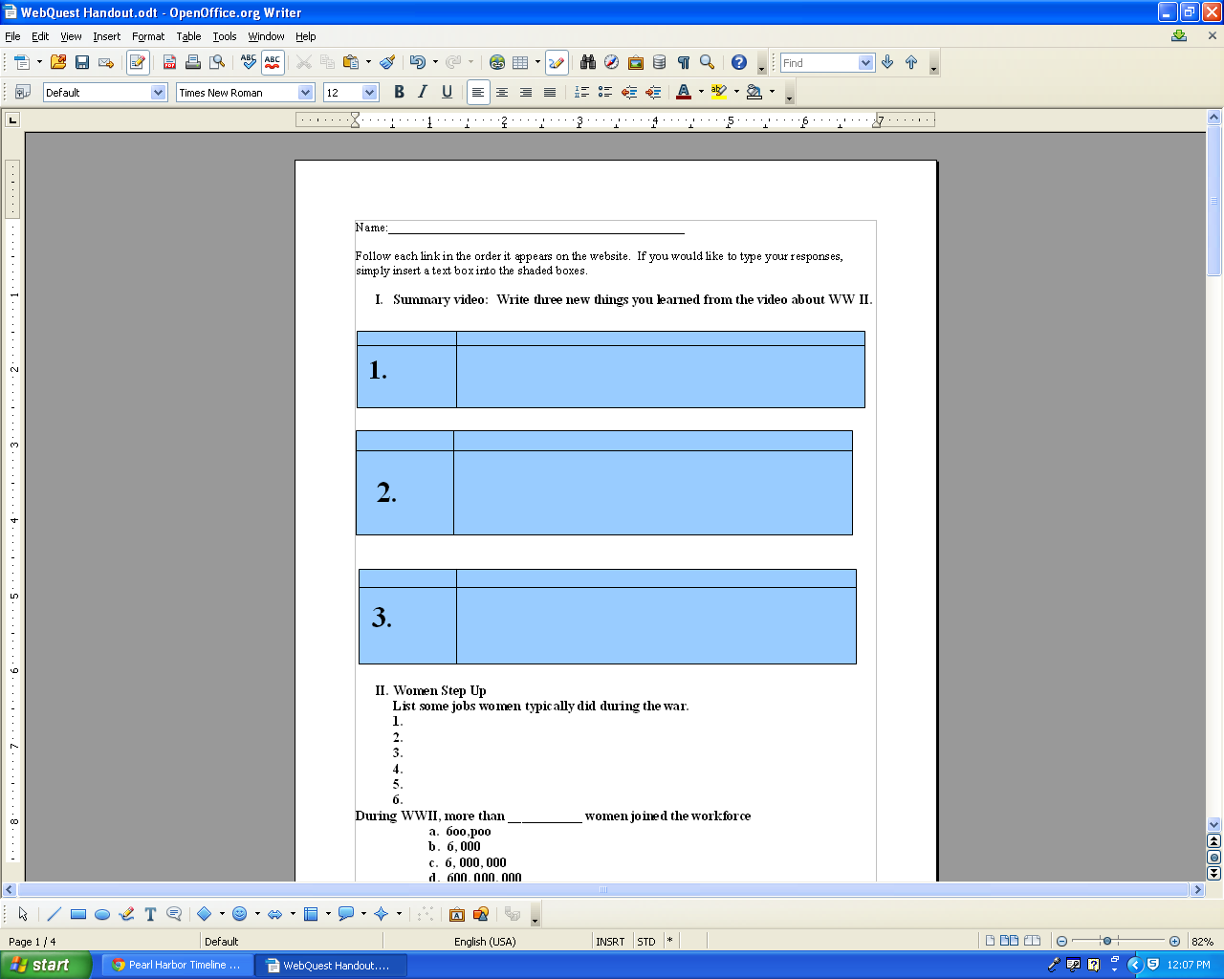
Follow each link in the order it appears on the website. If you would like to type your responses, simply insert a text box into the shaded boxes.

- Summary video: Write three new things you learned from the video about WW II.
1.
2.
3.

- Women Step Up
List some jobs women typically did during the war.
1.
2.
3.
4.
5.
6.

During WWII, more than ___________ women joined the workforce
a. 6oo,poo
b. 6, 000
c. 6, 000, 000
d. 600, 000, 000
Go to your internet browser and search for a current statistic on how many women are currently in the U.S. Workforce. Write it in the box.

How did things change when the war ended?

- Events leading up to the bombing of Pearl Harbor: On the time line, click on each time period, read, and write one fact in the corresponding box.
1600s to 1853: The “Black Ships” Open Japan
1860s: Japan: a Strong and Independent Nation

1898: American Becomes a Pacific Power
1929: The Great Depression

1937: China in Flames
1940: The Tripartite Pact

Fall, 1941 War Warning
Dec. 7, 1941The Day of Infamy

IV. Historical Overview of Japanese Internment
A. Who:

B. What:

C. Where:

D. Why:

E. When:

- Manzanar Investigation- Japanese American Internment Exploration
1.
2.

Write three new facts you learned from this link that weren't discussed in the overview (part III).

2.

3.
3.

- Photos of various camps. Write three adjectives that come to mind when viewing the photos. Explain each one.

- “Never Again”
Why do you think the victims would experience the pain and vulnerability of reliving their stories for the camera? How might their stories impact today's viewers? What lesson might viewers learn from their lives?

- You read the stories of Betty Reilly, Norman Mineta, and the Ganoses. Choose one person you read about and explain how his/her story impacted you. Make sure you summarize the story briefly in your explanation so that you can share it with your group.

