JSA Dance
Supply/Clothing List

www.dancewearsolutions.com (cheapest prices)
Dance Wear House- Canton, Ohio
Center Stage – Akron,Ohio

FEMALE UNIFORM:

Black Cotton/Nylon Leotard
Price Range: $12.99-25.00

Example: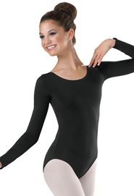 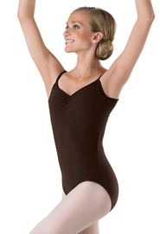 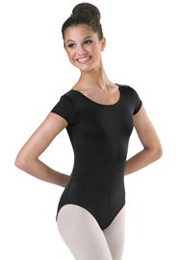

Pink and Black Convertible Tights
Price Range: $6.50-15.00

Example: 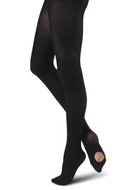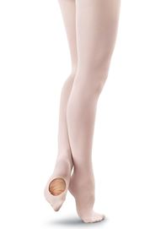

Ballet Shoes- Canvas Split Sole
Price Range: $12.95-30.00

Example: 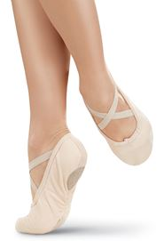

Jazz Shoes- Slip on or Tie up leather black
Price Range: $18.00-46.00

Example: 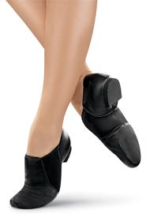 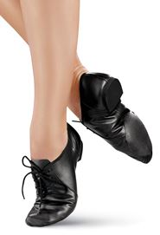

FEMALE & MALE

Tap Shoes- Leather Tie up Black/ NO SHINY BEGINNER TAP SHOES ALLOWED
*If planning on dancing all through JSA we suggest purchasing a high quality shoe. Lower grade tap shoes are great for lower level dance, but weaken as the training becomes more difficult.
Price Range: $19.95-51.00

Example: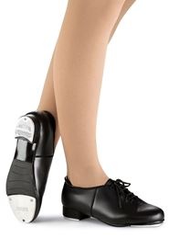

MALE UNIFORM

Ballet / Jazz shoe- Canvas ballet slipper (worn for both classes)
Price Range: $16.95-24.99

Example: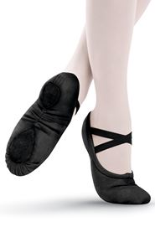

Black dance/running pants
Must be form fitted/ above ankle or at knee to avoid tripping
Avoid stripes and other patterns.
Price Range: Depends on store, try Walmart/Target/Kohls
Example: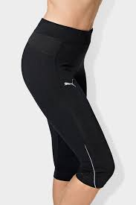 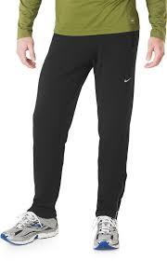

Male tops
Plain White/Black/Gray V neck or T Shirt
Price Range: Depends on store, try Walmart/Target/Kohls

Example: 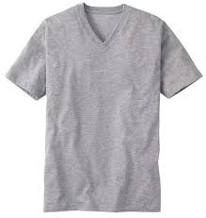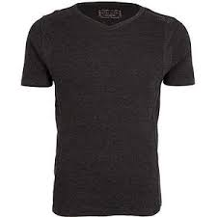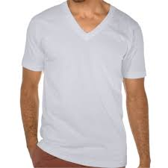

Suggested Options:

Dance Bra
Price Range: $9.99-24.00

Example:  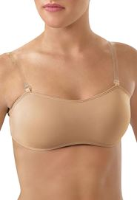

Black Nylon Shorts (worn only for Tap & Jazz)
Price Range: $12.95-20.00
Example: 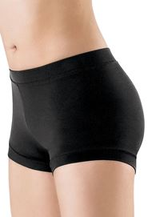

Male dance Belt
Price Range: $10.95-15.00

